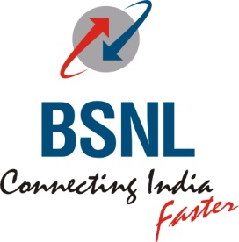
BHARAT SANCHAR NIGAM LIMITED
(A Govt of India Enterprise)
Office of the General Manager (Sales & Marketing) – Consumer Mobility,
16, Greams Road, Tamilnadu Circle, Chennai – 600 006.

[CSC SECTION]

No: CSC/ T-118/Proj.Smile/Vol-III/2010-12/75 dated @ CNI-6 the 6th APR 2011
To The Heads of all SSAs.
Tamilnadu Circle.

Sub: Extension of CCN Nodes to all Type III CSCs - reg.
Ref: BSNL CO, ND. Lr.No: 15-1/ 2010 – CSC dated 4.4.2011 (available on CSC
web portal and Corporate office intranet site)
*****
As you are aware, extension of CCN nodes to CSCs was envisaged as one key initiative of the ‘Project Smile’ in order to improve productivity and effectiveness of the CSCs. Further, based on the necessity and for optimizing resources, it was sought to be implemented in Type I & II CSCs only which were to have full bouquet of services and products. As per the roll-out plan and in absolute numbers, the initiative of extending CCN Node is nearly complete in majority of SSAs.
With the objective of enhancement of customer convenience by ensuring provisioning of mobility services at CSCs which may be at next door distance for the customers and improving productivity through online process, it has been decided that CCN Nodes shall be extended to all Type III CSCs in all SSAs.
By the term “extension of CCN node to all CSCs”, you may recollect that the following services are made available at CCN node at CSC: [source: page 21 of Blue Book].

- Prepaid SIM connections
- Postpaid new connections
- SIM replacement (faulty/lost)
- Barring of SIM in lost case
- Duplicate bill generation
- Request for itemised bill
- Activation / Deactivation of following services:
- Provision of STD
- Provision of SMS pack
- National roaming
- VAS
- Activation of DO Not Disturb
- Status check of facilities used by customer
- CAF collection from franchisees

It is hoped that connectivity and hardware required shall not be any serious issue and may be managed from the resources already available. However, if there are still any issues which require assistance from Circle Office, the same may be taken up with the CSC Cell of this office.
The target for completion of the job shall be 15th May 2011.

Sd.xxxxxxx
R.VASUDEVAN
DY.GENERAL MANAGER (CS) - CM

